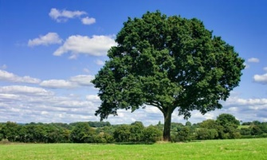
What Do We Plant?
-by Henry Abbey

What do we plant when we plant the tree?
We plant the ship, which will cross the sea.
We plant the mast to carry the sails;
We plant the planks to withstand the gales-
The keel, the keelson, the beam, the knee;
We plant the ship when we plant the tree.

What do we plant when we plant the tree?
We plant the houses for you and me.
We plant the rafters, the shingles, the floors,
We plant the studding, the lath, the doors,
The beams and siding, all parts that be;
We plant the house when we plant a tree.

What do we plant when we plant the tree?
A thousand things that we daily see;
We plant the spire that out-towers the crag,
We plant the staff for our country’s flag,
We plant the shade, from the hot sun free;
We plant all these when we plant the tree.

Life’s Mirror
-by Madeline Bridges

There are loyal hearts, there are spirits brave,
There are souls that are pure and true,
Then give the world the best you have,
And the best will come back to you.

Give love, and love to your life will flow,
A strength in your utmost need,
Have faith, and a score of hearts will show
Their faith in your word and deed.

Give truth, and your gift will be paid in kind;
And honor will honor meet;
And a smile that is sweet will surely find
A smile that is just as sweet.

Give pity and sorrow to those who mourn,
You will gather in flowers again
The scattered seeds from your thoughts outborne
Though the sowing seemed but vain.

For life is the mirror of king and slave,
'Tis just what we are and do;
Then give to the world the best you have,
And the best will come back to you.

The Perfect Pets
-by Dennis Lee
WAAAal-
I had a dog,
And his name was Doogie,
And I don't know why
But he liked to boogie;

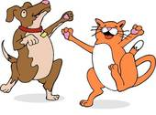
He boogied all night
He boogied all day
He boogied in a rude
Rambunctious way.

SOOOoo-
I got a cat,
And her name was Bing,
and I don't know why
But she liked to sing;

She sang up high
She sang down deep
She sang like the dickens
When I tried to sleep.
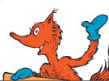
SOOOoo-
I got a fox,
And her name was knox,
And I don't know why
But she liked to box;

She boxed me out
She boxed me in
She boxed me smack!
On my chinny-chin-chin.

SOOOoo-
I got a grizzly,
And his name was Gus,
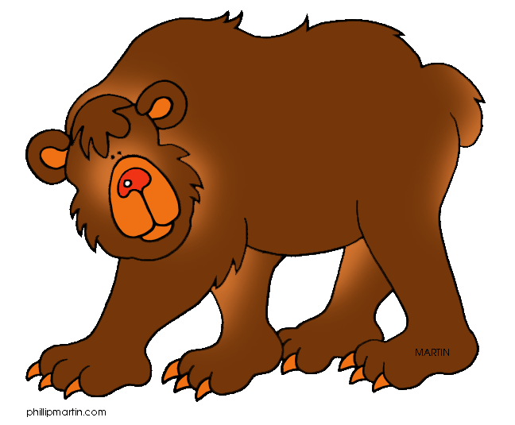
And I don't know why
But he liked to fuss,

He fussed in the sun
He fussed in the rain
He fussed till he drove me
Half insane!

NOWWWWww-
I don't know,
But I've been told
That some people's pets
Are good as gold.

But there's Doogie and there's Bing,
And there's Knox and Gus,
And they boogie and they sing
And they box and fuss;

So I'm giving them away
And I'm giving them for free-
If you want a perfect pet,
Just call on me.
Sneezles
-by A. A. Milne

Christopher Robin
Had wheezles
And sneezzles,
They bundled him
Into his bed.
They gave him what goes
With a cold in the nose,
And some more for a cold
In the head.
The wondered
If wheezzles
Could turn
Into measles,
Remember your grade is based on:
Title (5) Author (5) On Time (15)
Confidence (5)
Stand straight and tall, without fidgeting
Eye Contact (5)
Focus eyes on audience the entire time
Voice Level (5)
Speak loud and clear so that the entire class can hear you
Pacing & Fluency (5)
Poem is recited evenly (not rushed), pausing at commas, stopping at periods
Memorization (20)
The poem is in long-term memory. (Every time you pause to remember, it is one minus point)
Incorrect Words (5)
Words must be exactly what the author wrote
Skipped Words (10)
Every word is recited, none are skipped
Repeats (10)
No words or phrases are repeated
Animation/Enthusiasm (10)
In order to get an A, you need to include actions, props, or animation of some kind, throughout your poem.

94-100 = A
86-93 = B
77-85 = C
69-76 = D
69 or below = Redo poem

If sneezles
Would turn
Into mumps;

They examined his chest
For a rash,
And the rest
Of his body for swellings and lumps.
They sent for some doctors
In sneezles
And wheezles
To tell them what ought
To be done.

All sorts and conditions
Of famous physicians
Came hurrying round
At a run.
They all make a note
Of the state of his throat,
They asked if he suffered from thirst;
They asked if the sneezles
Came after the wheezles,
Or if the first sneezle
Came first.

The said, “if you teazle
A sneezle
Or wheezle,
A measle
May easily grow.
But humour and pleazle
The wheezle
Or sneezle,
The measle
Will certainly go.”
They expounded the reazles
For sneezles
And wheezles,
The manner of measles
When new.
They said, “If he freezles
In draughts and breezles,
The PHTHEEZLES
May even ensue.”

Christopher robin
Got up in the morning,
The sneezles had vanished away.
And the look in his eye
Seemed to say to the sky,
“Now, how to amuse them today?”

