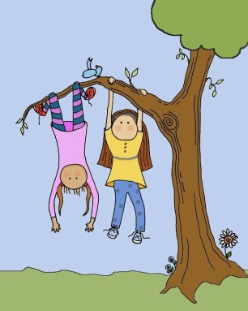
Every Time I Climb a Tree
-by David McCord

Every time I climb a tree
Every time I climb a tree
Every time I climb a tree
I scrape a leg
Or skin a knee
And every time I climb a tree
I find some ants
Or dodge a bee
And get the ants
All over me
And every time I climb a tree
Where have you been?
They say to me
But don't they know that I am free
Every time I climb a tree?
I like it best
To spot a nest
That has an egg
Or maybe three
And then I skin
The other leg
But every time I climb a tree
I see a lot of things to see
Swallows rooftops and TV
And all the fields and farms there be
Every time I climb a tree
Though climbing may be good for ants
It isn't awfully good for pants
But still it's pretty good for me
Every time I climb a tree.
Raindrops
-by Harry Behn

They tap like fingers on the window pane,
But they aren't fingers, they are only rain.

They fall the way bees do into a flower,
But they aren't bees; they're pieces of a shower.

They jump in puddles just like little men,
Then they aren't ever even rain again,

They're simply water wrinkled by the motion
Of streams and rivers till they're only ocean.

But ocean turns to waves, and waves to sprays
And mist, and sometimes on a sunny day

Mist sails up to the sky above the shrouds
Of ships and there wind blows it into clouds.

Then raindrops fall again. Unless they're snow.
My teacher told me this, and so it's so.

Coloring
-by Harry Behn

A rake, a coat, a meadow, a mill,
A cake, a boat, a house on a hill,
A kite, a spade, and a ball of string,
A wind in the leaves, and the song birds sing-
It's Spring!
We're outdoors coloring
Every bright beautiful wonderful thing.

Under a lilac bush we've made
A studio with walls of shade,
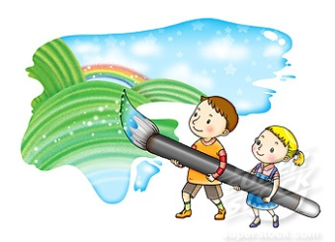
And in our painting books we spread
Pools of yellow, blue, and red-
Carefully,
Though it doesn't matter
Terribly much unless we spatter.

Green and red, and there's a tree
With apples and cherries, and here's a sea
With a wave and a sky and a gull in flight,
And this is the sun
splashing light-
It's Spring!
We're coloring, and all the birds sing
Of every bright beautiful wonderful thing!

Patience
-by Bobbi Katz

Chocolate Easter bunny
In a jelly bean nest,
I'm saving you for very last
Because I love you best.
I'll only take a nibble
From the tip of your ear
And one bite from the other side
So that you won't look queer.
Yum, you're so delicious!
I didn't mean to eat
Your chocolate tail till Tuesday
Oops! There go your feet!
I wonder how your back tastes
With all that chocolate hair.
I never thought your tummy
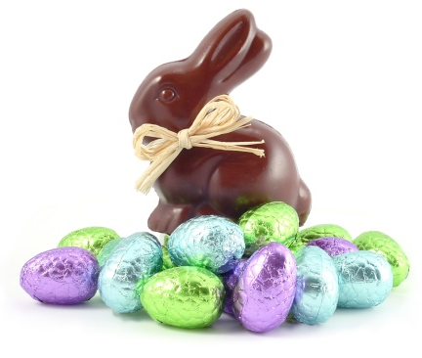
Was only filled with air!
Chocolate Easter bunny
In a jelly bean nest,
I'm saving you for very last
Because I love you best.

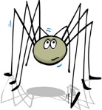
Mr. Bidery's Spidery Garden
-by David McCord

Poor old Mr. Bidery,
His garden's awfully spidery:
Bugs use it as a hidery.

In April it was seedery,
By May a mass of weedery;
And oh, the bugs! How greedery.

White flowers out or buddery,
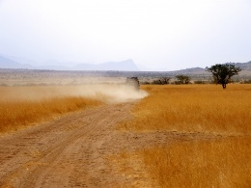
Potatoes made it spuddery;
And when it rained, what muddery!

June days grow long and shaddery;
Bullfrog forgets his taddery;
The spider legs his laddery.

With cabbages so odory,
Snapdragon soon explodery,
At twilight all is toadery.

Young corn still far from foddery
No sign of goldenrodery,
Yet feeling low and doddery

Is poor old Mr. Bidery,
Remember your grade is based on:
Title (5) Author (5) On Time (15)
Confidence (5)
Stand straight and tall, without fidgeting
Eye Contact (5)
Focus eyes on audience the entire time
Voice Level (5)
Speak loud and clear so that the entire class can hear you
Pacing & Fluency (5)
Poem is recited evenly (not rushed), pausing at commas, stopping at periods
Memorization (20)
The poem is in long-term memory. (Every time you pause to remember, it is one minus point)
Incorrect Words (5)
Words must be exactly what the author wrote
Skipped Words (10)
Every word is recited, none are skipped
Repeats (10)
No words or phrases are repeated
Animation/Enthusiasm (10)
In order to get an A, you need to include actions, props, or animation of some kind, throughout your poem.
His garden lush and spidery,
His apples green, not cidery.

Pea-picking is so poddery!

94-100 = A
86-93 = B
77-85 = C
69-76 = D
69 or below = Redo poem

Foreign Lands
-by Robert Louis Stevenson

UP into the cherry tree
Who should climb but little me?
I held the trunk with both my hands
And looked abroad on foreign lands.

I saw the next-door garden lie,
Adorned with flowers, before my eye,
And many pleasant faces more
That I had never seen before.

I saw the dimpling river pass
And be the sky’s blue looking-glass;
The dusty roads go up and down
With people tramping in to town.

If I could find a higher tree
Farther and farther I should see,
To where the grown-up river slips
Into the sea among the ships,

To where the roads on either hand
Lead onward into fairy land,
Where all the children dine at five,
And all the playthings come alive.

