4th Term Poems

Snowflakes
-by David McCord

Sometime this winter if you go
To walk in soft new falling snow
When flakes are big and come down slow

To settle on your sleeve as bright
As stars that couldn't wait for night,
You won't know what you have in sight -

Another world - unless you bring
A magnifying glass. This thing
We call a snowflake is the king

Of crystals. Do you like surprise?
Examine him three times his size:
At first you won't believe your eyes.

Stars look alike, but flakes do not:
No two the same in all the lot
That you will get in any spot

You chance to be, for every one
Come spinning through the sky has none
But his own window-wings of sun:

Joints, points, and crosses. What could make
Such lacework with no crack or break?
In billions, billions, no mistake?

Sleepy Harry
-by Kate Greenaway

“I do not like to go to bed,”
Sleepy little Harry said;
“Go, naughty Betty, go away,
I will not come at all, I say!”

Oh, silly child! What is he saying!
As if he could be always playing!
Then, Betty, you must come and carry
This very foolish little Harry.

The little birds are better taught,
They go to roosting when they ought;
And all the ducks, and fowls, you know,
They went to bed an hour ago.

The little beggar in the street,
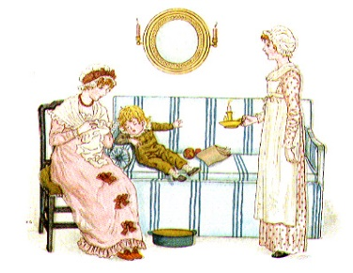
Who wanders with his naked feet,
And has not where to lay his head,
Oh, he’d be glad to go to bed.

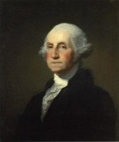

Washington
-by Nancy Byrd Turner

He played by the river when he was young,
He raced with rabbits along the hills,
He fished for minnows, and climbed and swung,
And hooted back at the whippoorwills.
Strong and slender and tall he grew--
And then, one morning, the bugles blew.

Over the hills the summons came,
Over the river's shining rim.
He said that the bugles called his name,
He knew that his country needed him,
And he answered, "Coming!" and marched away
For many a night and many a day.

Perhaps when the marches were hot and long
He'd think of the river flowing by
Or, camping under the winter sky,
Would hear the whippoorwill's far-off song.
Boy or soldier, in peace or strife,
He loved America all his life!

Lincoln
-by Nancy Byrd Turner

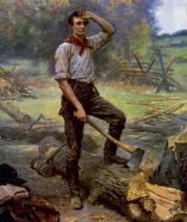
There was a boy of other days,
A quiet, awkward, earnest lad,
Who trudged long weary miles to get
A book on which his heart was set-
And then no candle had!

He was too poor to buy a lamp
But very wise in woodmen's ways.
He gathered seasoned bough and stem,
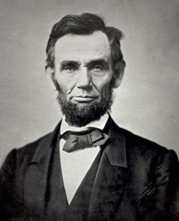
And crisping leaf, and kindled them
Into a ruddy blaze.

Then as he lay full length and read,
The firelight flickered on his face,
And etched his shadow on the gloom,
And made a picture in the room,
In that most humble place.

The hard years came, the hard years went,
But gentle, brave, and strong of will,
He met them all. And when today
We see his pictured face, we say,
"There's light upon it still."

Jimmy Jet and His TV Set
-by Shel Silverstein

I’ll tell you the story of Jimmy Jet –
And you know what I tell you is true.
He loved to watch his TV set
Almost as much as you.

He watched all day, he watched all night
‘Till he grew pale and lean,
From “The Early Show” to “The Late Late Show”
And all the shows between.

He watched till his eyes were frozen wide,
And his bottom grew into his chair.
And his chin turned into a tuning dial,
And antennae grew out of his hair.

And his brains turned into TV tubes,
And his face to a TV screen.
And two knobs saying “VERT.” and “HORIZ.”
Grew where his ears had been.

And he grew a plug that looked like a tail
So we plugged in little Jim.
And now instead of him watching TV
We all sit around and watch him.
Remember your grade is based on:
Title (5) Author (5) On Time (15)
Confidence (5)
Stand straight and tall, without fidgeting
Eye Contact (5)
Focus eyes on audience the entire time
Voice Level (5)
Speak loud and clear so the entire class can hear you
Pacing & Fluency (5)
Poem is recited evenly (not rushed), pausing at commas, stopping at periods
Memorization (20)
The poem is in long-term memory. (Every time you pause to remember, it is one minus point)
Incorrect Words (5)
Words must be exactly what the author wrote
Skipped Words (10)
Every word is recited, none are skipped
Repeats (10)
No words or phrases are repeated
Animation/Enthusiasm (10)
In order to get an A, you need to include actions, props, or animation of some kind, throughout your poem.

The Little Hill
-by Harry Behn

Windy shadows race
Over a hilly place
I know, a sunny place,
A secret place.

It's not so far away,
I go there every day,
Every bright windy day
I go there to play.

Over the garden wall
I climb and jump and fall
Into weeds by the wall,
And then I crawl

As quiet as can be
Under a hollow tree
Where once a bumble bee
Bumbled at me.

Then still, so very still
Through shade I go until
I see my little hill
Sunny and still.

Up through the pleasant sun
Up to the top I run
Higher than everyone
Under the sun,

High up until I see
Over the tallest tree,
Over town to the sea,
The blue sea. . .

Here no one ever goes
Because here nothing grows,
Only weeds and wild rose,
And no one knows

Hidden by woods and vine
Far up in the sun shine
This little hill is mine,
This hill is mine.
94-100 = A
86-93 = B
77-85 = C
69-76 = D
69 or below = Redo poem

