3rd Term Poems

The Frost Pane
by David McCord

What's the good of breathing
On the window
Pane
In summer?
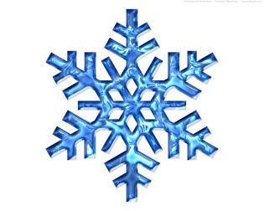
You can't make a frost
on the window pane
In summer.
You can't write a
Nalphabet
You can't draw a
Nelehant.
You can't make a smudge
With your nose
In summer.
Lots of good, breathing
On the window
Pane
In winter.
You can make a frost
On the window pane
In winter.
A white frost, a light frost,
A thick frost, a quick frost,
A write-me-out-a-picture-frost
Across the pane
In winter.
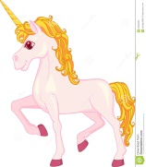

Unicorn
by William Jay Smith

The Unicorn with the long white horn
Is beautiful and wild.
He gallops across the forest green
So quickly that he’s seldom seen
Where Peacocks their blue feathers preen
And strawberries grow wild.
He flees the hunter and the hounds,
Upon black earth his white hoof pounds,
Over cold mountain streams he bounds
And comes to a meadow mild;
There, when he kneels to take his nap,
He lays his head in a lady’s lap
As gently as a child.

Adventures of Isabel
by Ogden Nash
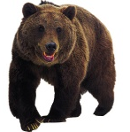
Isabel met an enormous bear,
Isabel, Isabel didn’t care.
The bear was hungry,
the bear was ravenous,
The bear’s big mouth
was cruel and cavernous.
The bear said, “Isabel, glad to meet you,
How do, Isabel, now I’ll eat you!”
Isabel, Isabel didn’t worry;
Isabel didn’t scream or scurry,
She washed her hands and
she straightened her hair up
Then Isabel quietly ate the bear up.

Once in a night as black as pitch
Isabel met a wicked old witch.
the witch's face was cross and wrinkled,
The witch's gums with teeth were sprinkled.
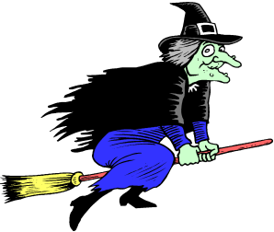
“Ho, ho, Isabel!” the old witch crowed,
I'll turn you into an ugly toad!
Isabel, Isabel, didn't worry,
Isabel didn't scream or scurry,
She showed no rage
and she showed no rancor,
But she turned the witch
into milk and drank her.

On Our Way
by Eve Merriam

What kind of walk shall we take today?
Leap like a frog? Creep like a snail?
Scamper like a squirrel with a furry tail?
Flutter like a butterfly? Chicken peck?
Stretch like a turtle with a poking-out neck?
Trot like a pony, clip clop clop?
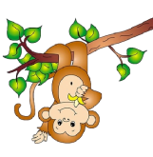
Swing like a monkey in a treetop?
Scuttle like a crab? Kangaroo jump?
Plod like a camel a camel with an up-and-down hump?
We could even try a brand-new way -
Walking down the street
On our own two feet.
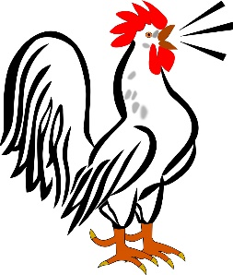
Written in March
by William Wordsworth

The cock is crowing,
The stream is flowing,
The small birds twitter,
The lake doth glitter
The green field sleeps in the sun;
The oldest and youngest
Are at work with the strongest;
The cattle are grazing,
Their heads never raising;
There are forty feeding like one!

Like an army defeated
The snow hath retreated,
And now doth fare ill
On the top of the bare hill;
The plowboy is whooping—anon-anon:
There's joy in the mountains;
There's life in the fountains;
Small clouds are sailing,
Blue sky prevailing;
The rain is over and gone!

Humanity
by Elma Stuckey

If I am blind and need someone
To keep me safe from harm,
It matters not the race to me
Of the one who takes my arm.

If I am saved from drowning
As I grasp and grope,
Remember your grade is based on:
Title (5)
Author (5)
On Time (15)
Confidence (5)
Stand straight and tall, without fidgeting
Eye Contact (5)
Focus eyes on audience the entire time
Voice Level (5)
Speak loud and clear so that the entire class can hear you
Pacing & Fluency (5)
Poem is recited evenly (not rushed), pausing at commas, stopping at periods
Memorization (20)
The poem is in long-term memory. (Every time you pause to remember, it is one minus point)
Incorrect Words (5)
Words must be exactly what the author wrote
Skipped Words (10)
Every word is recited, none are skipped
Repeats (10)
No words or phrases are repeated
Animation/Enthusiasm (10)
In order to get an A, you need to include actions, props, or animation of some kind, throughout your poem.

94-100 = A
86-93 = B
77-85 = C
69-76 = D
69 or below = Redo poem
I will not stop to see the face
Of the one who throws the rope.

Or if out on some battlefield
I'm falling faint and weak,
The one who gently lifts me up
May any language speak.

We sip the water clear and cool,
No matter the hand that gives it.
A life that's lived worthwhile and fine,
What matters the one who lives it?

