2nd Term Poems

What is Orange?
by Mary O’Neill

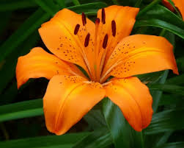
Orange is a tiger lily,
A carrot,
A feather from
A parrot,
A flame,
The wildest color
You can name.
Orange is a happy day
Saying good-by
In a sunset that
Shocks the sky.
Orange is brave
Orange is bold
It’s bittersweet
And marigold.
Orange is zip
Orange is dash
The brightest stripe
In a Roman sash.
Orange is an orange
Also a mango
Orange is music
Of the Tango.
Orange is the fur
Of the fiery fox,
The brightest crayon
In the box.
And in the fall
When leaves are turning
Orange is the smell
Of a bonfire burning…
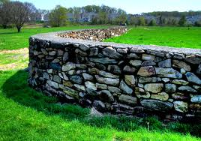

A Time to Talk
by Robert Frost

When a friend calls to me from the road
And slows his horse to a meaning walk,
I don't stand still and look around
On all the hills I haven't hoed,
And shout from where I am, "What Is It?"
No, not as there is a time to talk.
I thrust my hoe in the mellow ground,
Blade-end up and five feet tall,
And plod: I go up to the stone wall
For a friendly visit.
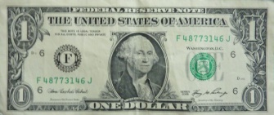
Smart
by Shel Silverstein

My dad gave me one dollar bill
‘Cause I’m his smartest son,
And I swapped it for two shiny quarters
‘Cause two is more than one!

And then I took the quarters
And traded them to Lou
For three dimes – guess he don’t know
That three is more than two!

Just then, along came old blind Bates
And just ‘cause he can’t see
He gave me four nickels for my three dimes,
And four is more than three!

And I took the nickels to Hiram Coombs
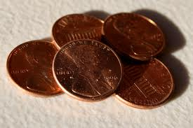
Down at the seed-feed store,
And the fool gave me five pennies for them,
And five is more than four!

And then I went and showed my dad,
And he got red in the cheeks,
And closed his eyes and shook his head –
Too proud of me to speak!

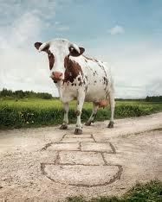
Different Things
by Harry Behn

Cows don’t play hop-scotch
Any more than pigs,
Kittens never cackle ever
The way a dog digs,
Or bees buzz or birds fly
Or bubbles float or babies cry,
Still, why they do or don’t it seems
I only understand in dreams.

Some times I wonder
If it wouldn’t be fun
To let trees go where they please
Or make the moon the sun.
But then my shoes would be my hat,
And so I leave things this or that
About the way they are, but funny
Like bread and buttercups and honey.
What is Red?
By Mary O’Neill

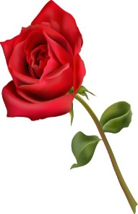
Red is a sunset
Blazy and bright.
Red is feeling brave
With all your might.
Red is a sunburn
Spot on your nose,
Sometimes red
Is a red, red rose.
Red squiggles out
When you cut your hand.
Red is a brick and
A rubber band.
Red is hotness
You get inside
When you’re embarrassed
And want to hide.
Fire-cracker, fire-engine
Fire-flicker red –
And when you’re angry
Red runs through your head.
Remember your grade is based on:
Title (5) Author (5) On Time (15)
Confidence (5)
Stand straight and tall, without fidgeting
Eye Contact (5)
Focus eyes on audience the entire time
Voice Level (5)
Speak loud and clear so that the entire class can hear you
Pacing & Fluency (5)
Poem is recited evenly (not rushed), pausing at commas, stopping at periods
Memorization (20)
The poem is in long-term memory. (Every time you pause to remember, it is one minus point)
Incorrect Words (5)
Words must be exactly what the author wrote
Skipped Words (10)
Every word is recited, none are skipped
Repeats (10)
No words or phrases are repeated
Animation/Enthusiasm (10)
In order to get an A, you need to include actions, props, or animation of some kind, throughout your poem.
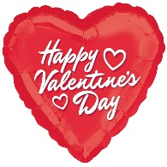
Red is an Indian,
A Valentine heart,
The trimming on
A circus cart.
Red is a lipstick,
Red is a shout,
Red is a signal
That says: “Watch out!”
Red is a great big
Rubber ball.
Red is the giant-est
Color of all.
Red is a show-off
No doubt about it –
But can you imagine
Living without it?

94-100 = A
86-93 = B
77-85 = C
69-76 = D
69 or below = Redo poem

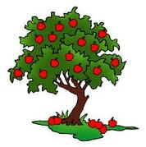
The Boys and the Apple Tree
By Kate Greenaway

As William and Thomas were walking one day,
They came by a fine orchard’s side:
They would rather eat apples that spell, read, or play,
And Thomas to William then cried:

O brother, look yonder! What clusters hang there!
I’ll try and climb over the wall:
I must have an apple; I will have a pear;
Although it should cost me a fall!”

Said William to Thomas, “To steal is a sin,
Mamma has oft told this to thee:
I never have stolen, nor will I begin,
So the apples may hang on the tree.”

