**FIRST TERM POEMS**

C:\Users\Dave\AppData\Local\Microsoft\Windows\INetCache\IE\TO2OZVPU\MC900437457[1].wmf**Afternoon on a Hill**

*By Edna St. Vincent Millay*

I will be the gladdest thing

Under the sun!

I will touch a hundred flowers

And not pick one.

I will look at cliffs and clouds

With quiet eyes,

Watch the wind blow down the grass,

And the grass rise.

And when lights begin to show

Up from the town,

I will mark which must be mine,

And then start down!

**Summer Shower**

*By David McCord*

Window window window pane:

Let it let it let it rain

Drop by drop by drop by drop.

Run your rivers from the top

Zigzaggy down, like slow wet forks

Of lightning, so the slippery corks

Of bubbles float and overtake

Each other till three bubbles make

A kind of boat too fat to fit

The river. That's the end of it.

 Straight

down

it

slides

and

with

a

splash

Is lost against the window sash.

Window window window pane:

Let it let it let it rain.

**Growing Up**

*By Harry Behn*

When I was seven

We went for a picnic

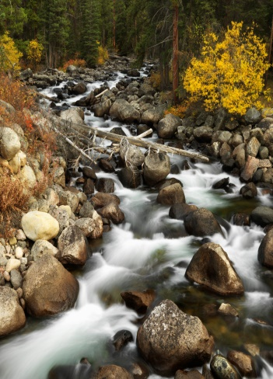Up to a magic

Foresty place.

I knew there were tigers

Behind every boulder,

Though I didn't meet one

Face to face.

When I was older

We went for a picnic

Up to the very same

Place as before,

And all of the trees

And rocks were so little

They couldn't hide tigers

Or me anymore.

**Tired**

*By Shel Silverstein*

I've been working so hard you just wouldn't believe,

And I'm tired!

There's so little time and so much to achieve,

And I'm tired!

I've been lying here holding the grass in its place,

Pressing a leaf with the side of my face.

Tasting the apples to see if they're sweet,

Counting the toes on a centipede's feet.

I've been memorizing the shape of that cloud,

Warning the robins to not chirp so loud,

Shooing the butterflies off the tomatoes,

Keeping an eye out for floods and tornadoes.

I've been supervising the work of the ants

And thinking of pruning the cantaloupe plants,

Timing the sun to see what time it sets,

Calling the fish to swim into my nets,

C:\Users\Dave\AppData\Local\Microsoft\Windows\INetCache\IE\55MX32YP\MC900232905[1].wmfAnd I've taken twelve thousand and forty-one breaths,

And I'm TIRED!

****Early**

**Remember your grade is based on:**

**Title (5)**

**Author (5)**

**On Time (15)**

**Confidence (5)**

Stand straight and tall, without fidgeting

**Eye Contact (5)**

Focus eyes on audience the entire time

**Voice Level (5)**

Speak loud and clear so that the entire class can hear you

**Pacing & Fluency (5)**

Poem is recited evenly (not rushed), pausing at commas, stopping at periods

**Memorization (20)**

The poem is in long-term memory. (Every time you pause to remember, it is one minus point)

**Incorrect Words (5)**

Words must be *exactly* what the author wrote

**Skipped Words (10)**

Every word is recited, none are skipped

**Repeats (10)**

No words or phrases are repeated

**Animation/Enthusiasm (10)**

In order to get an A, you need to include actions, props, or animation of some kind, *throughout your poem*.

94-100 = A

86-93 = B

77-85 = C

69-76 = D

69 or below = Redo poem

*By Harry Behn*

Before the sun was quite awake

I saw the darkness like a lake

Float away in a little stream

As swift and misty as a dream.

It left the morning oh so still

Except when once a whippoorwill

Up in the orchard whispered a word

And once a frog trilled like a bird.

Then I could only think of me,

And what a nicer child I'd be

If I could learn to walk as still

As morning sunlight on a hill.



**Weather**

*By Eve Merriam*

Dot a dot dot dot a dot dot

Spotting the windowpane.

Spack a spack speck flick a flack fleck

Freckling the windowpane.

A spatter a scatter a wet cat a clatter

A splatter a rumble outside.

Umbrella umbrella umbrella umbrella

Bumbershoot barrel of rain.

Slosh a galosh slosh a galosh

Slither and slather a glide

A puddle a jump a puddle a jump

A puddle a jump puddle splosh

A juddle a pump aluddle a dump a

Puddmuddle jump in and slide!